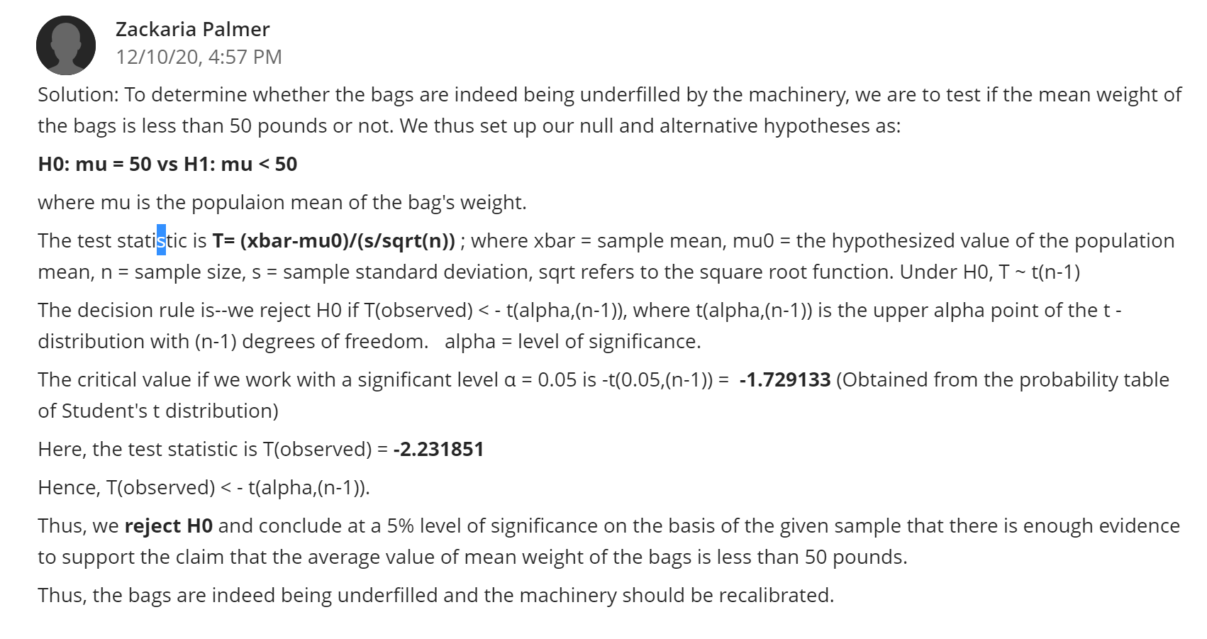
Reply 1
Statistics is utilized in the business setting to test the efficacy and effectiveness of a certain project. Lucky enough, your study is critical, more notably, in determining whether the machine underfills the bags as an example to apply the statistical concept. Therefore, the organizations are expected to come up with null and alternative hypothesis to underpin where a particular operation falls, that is, acceptance or rejection region. I would also like to add something on the degree of freedom that you used in this study. Degree of freedom indicates the independent values number varying in an analysis with an aim to not break any constraints. This ideology is essential and it is reflected in many contexts such as probability distribution, hypothesis tests including regression analysis. When you relate this idea with your study, you realize that your research focused on hypothesis testing. I agree that null hypothesis is supposed to be rejected based on the evidence retrieved from the student’s t distribution probability table. Thus, the organization should enhance the machinery to meet its set objective.
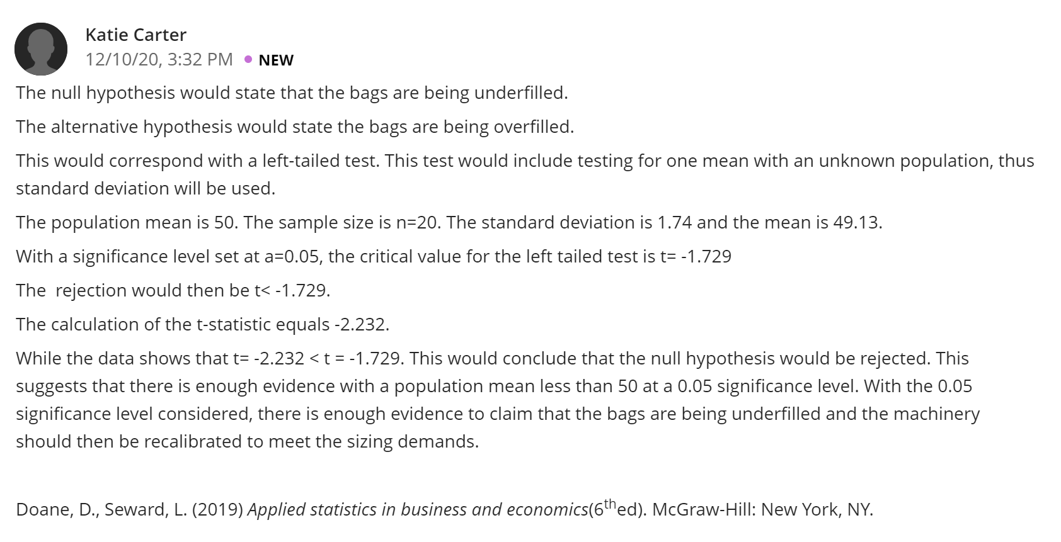
Reply 2
Null and alternative hypothesis contrast each other, for instance, in your study, null hypothesis states that the bags are being underfilled and on the other hand, alternative hypothesis states that the bags are being underfilled. Considering this situation, it is crucial to apply both hypothesis as far as testing of hypothesis is concerned. Consequently, the organization will make solid decision in respect of the evidence showcased in not only null hypothesis but also alternative hypothesis. Still, null hypothesis is rejected because t=-2.232 gotten from calculation is less than t=-1.729 and in this case, the sample lied on the rejection region. Definitely, the organization should improve the machinery to achieve the seizing demands. For the most part, your study can escalate the financial performance of the organization when it applies statistics to identify a problem in the operation and take affirmative action to curb the same.

